INFOPACK

Next Re-Generation Vol. IV
4 ESC LONG TERM volunteers
(1 participant with fewer opportunities)

February 14th - September 27th 2024
At COB eco-project at Nessonas (Larissa), Greece
Age of participants: 18-30
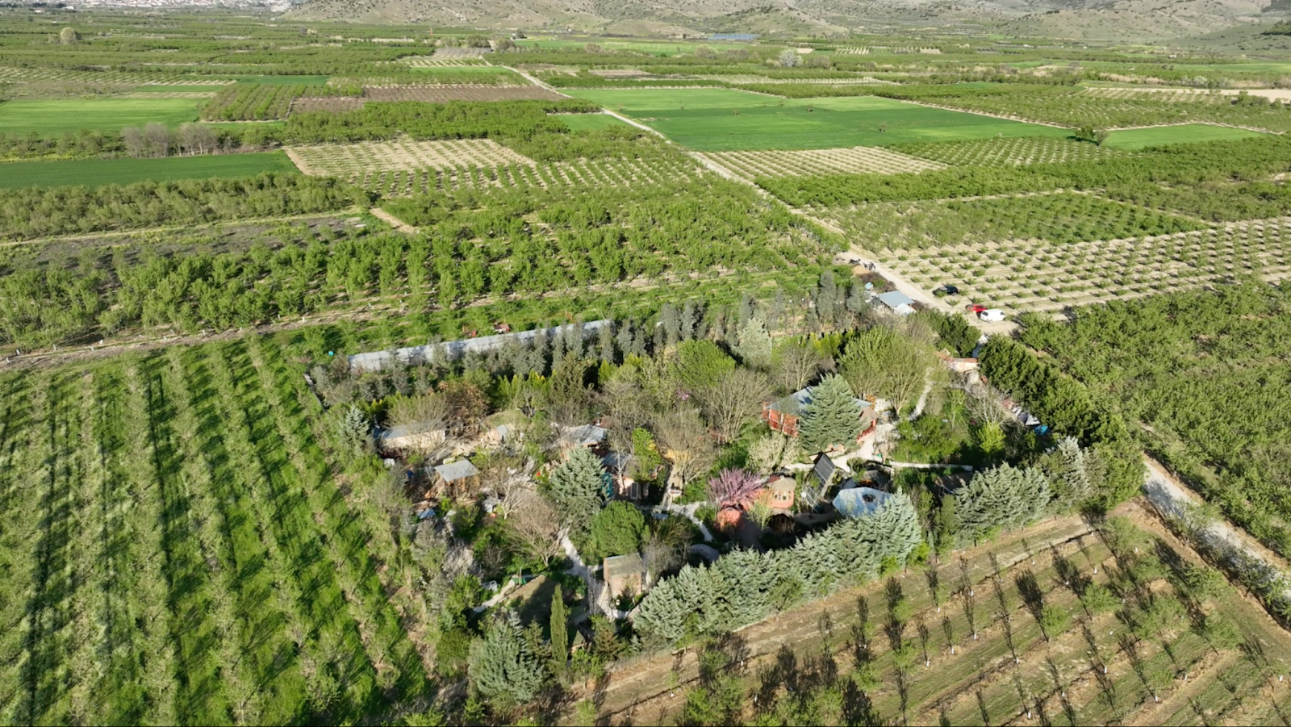

Hosting Organization Official Website: www.cob.gr
Facebook: https://www.facebook.com/buildingwithearth/
Instagram: https://www.instagram.com/cob_gr/

Information Package:

1. General information
2. Accommodation
3. Travel Information
4. What to bring
5. Activities
6. Disclaimer
7. Confirmation
1. General Information
1.1 TIMELINE

Arrival date: February 13th 2024
Departure date: September 28th 2024 (Or never!)

Please respect the dates of arrival and departure. If you need to come earlier or leave later, please send us an email to efstathia.sideris@gmail.com and xkontom@gmail.com. You are also eligible for Green Travel (bus, train, car-pooling, boat) with 4-6 travel days roundtrip. Please keep all your travel documents with you until your arrival to the activity venue or we will not be able to reimburse you with the travel money.
Nevertheless it is necessary that you attend the volunteering programme from the beginning to the end, so please arrange your travel accordingly.

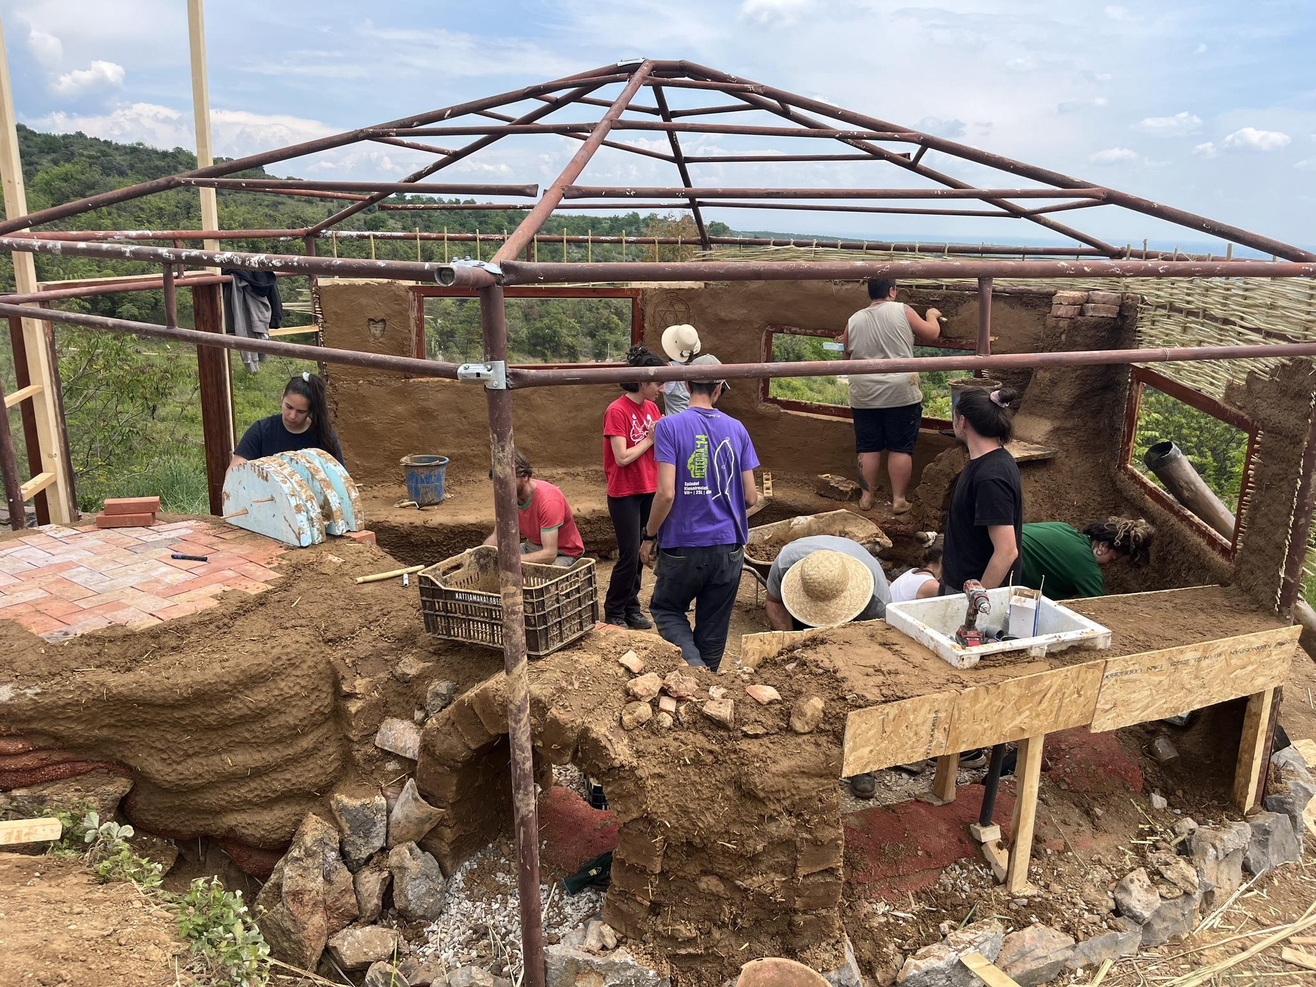
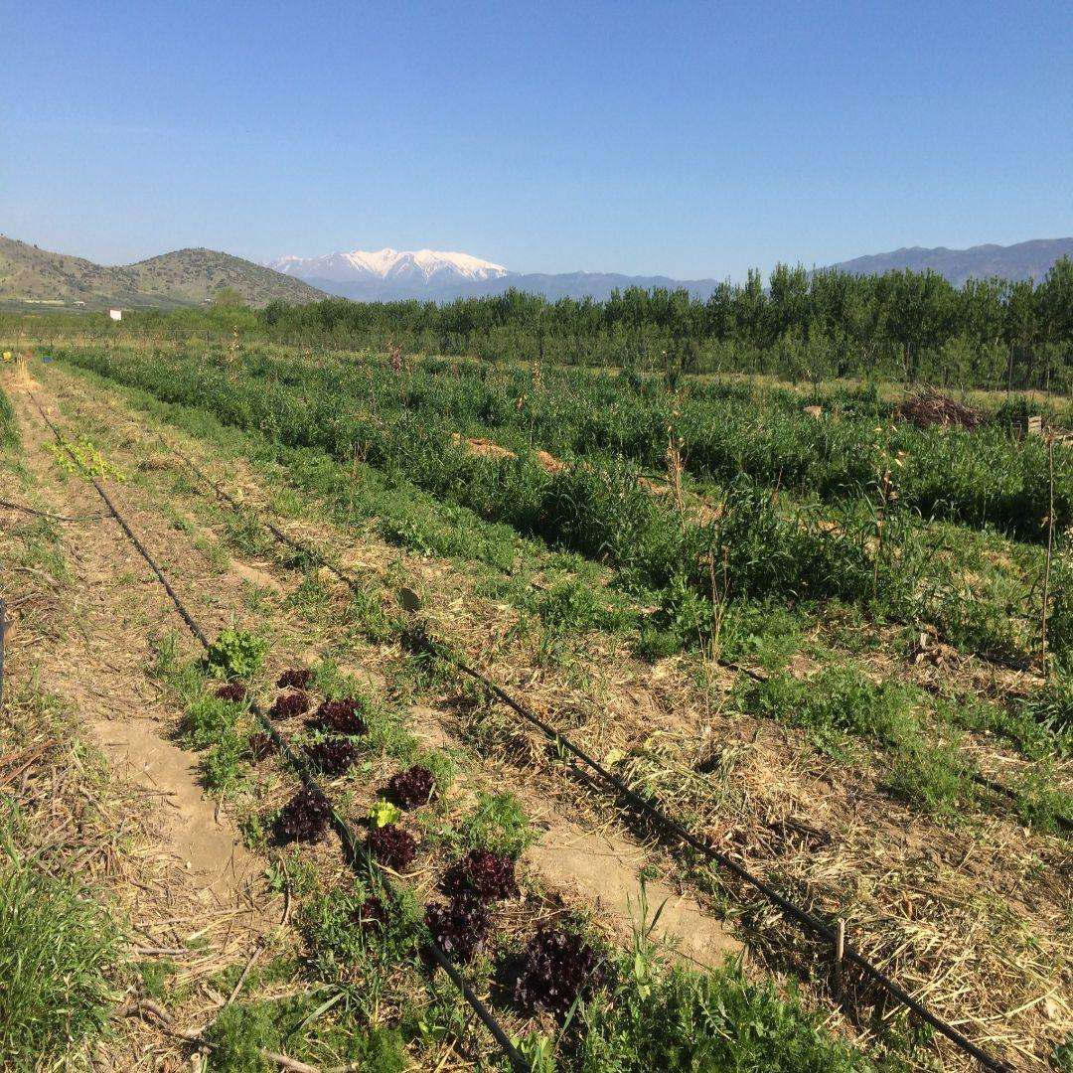

1.2 VENUE

Eco-project COB project in Nessonas (Larissa), Greece
The COB eco-project is a permaculture farm and an intentional community that is specialized in natural building, regenerative farming and alternative technologies.
The COB eco-project is a social cooperative of sustainable development which primarily started as an educational project to spread the know-how, the philosophy, theory and practice of natural building and bioclimatic architecture guided by the safe and sustainable management of resources and energy. Our organization has been active in the field of youth and adult education for more than seventeen years. It has developed its own training methods, workshops, and courses and has organized multiple educational activities on sustainability and ecology.

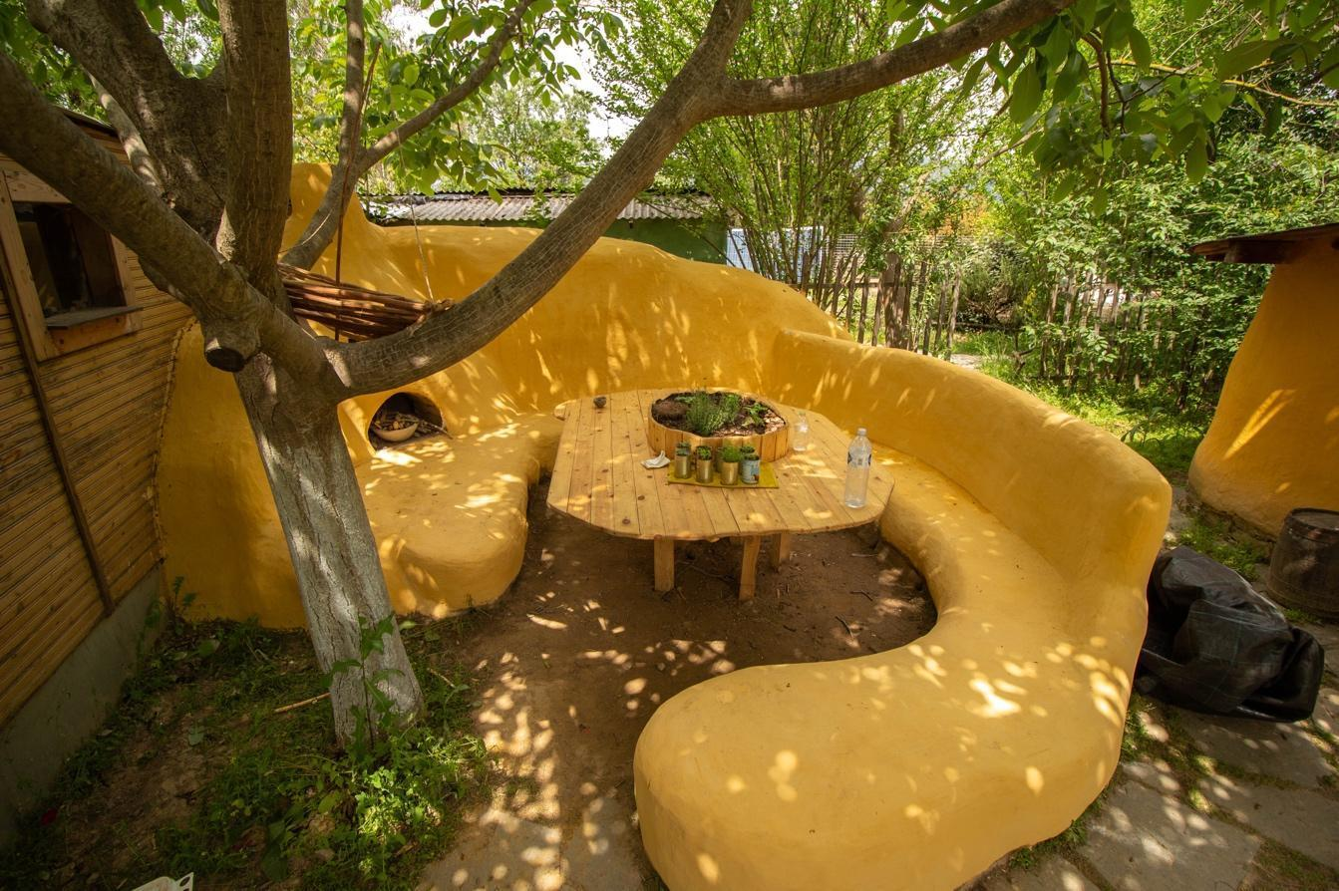
Workshops for young people run here frequently and every year more and more long term volunteers are following their intuitive learning path through the practical exploration and implementation of techniques and practices like cob ecobuilding, permaculture design, natural farming, agroforestry, healthy nutrition, zero waste lifestyle, renewable energy solutions, non violent communication and group decision making techniques like sociocracy. Moreover, our farm acts as a hub that connects young people with other projects in Greece and abroad, to support them in following their intuitive learning path and deepen their knowledge in their topic of interest and to strengthen the community of eco-projects throughout Greece and all Europe.
For more pictures and information visit our website: www.cob.gr
Facebook page: https://www.facebook.com/buildingwithearth/
Instagram account: https://www.instagram.com/cob_gr/
1.3 CONTACT DETAILS
- Christos cell phone: 0030 6973970075
- Efstathia’s whatsapp: 0030 6946346258
- The best way is to contact us via mail: efstathia.sideris@gmail.com and xkontom@gmail.com

2. Accommodation
This Volunteering Activity will take place in the COB farm, in central Greece.
Volunteers will be staying in the farm buildings and houses made of natural materials. It is necessary that you bring your own outdoors sleeping material to be comfortably sleeping outdoors in case of outdoor excursions. Have in mind that there are also mosquitos during summer so make sure you bring a natural mosquito repellent. Tents can be provided by the organisation.
Compost toilets and outdoor showers will serve our needs.
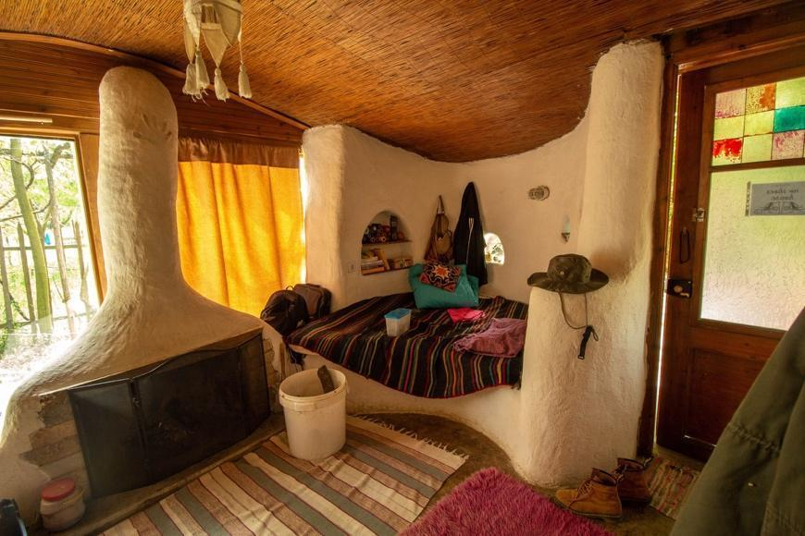
As we try to live in balance with our surrounding ecosystem, and the food forest, we are using water consciously. Also please bring plant based fully biodegradable toiletry (shampoo, soaps, toothpaste, mosquito repellents etc.) so the water of the shower and the sink doesn’t harm nature. If you don't have any, we can provide you with a toiletry kit for 7€.
The house on the farm provides us with a kitchen to cook our daily meals, which are healthy and VEGAN. If you have any allergies or intolerances, please inform us ahead of time, so we can plan accordingly.
There is some internet access on the farm, close to the house, but don´t forget to connect with nature, rather than with the internet.
What’s more, the farm is off-grid and we are energy supplied by a solar panel system, so electricity is limited. You have to consider that our system cannot support heavy energy devices like hair-dryers. All the devices (tablets, cell phones. etc.) should be charged during the daytime. If there is an extended period without sun (heavy clouds/rain), we avoid spending any energy at all, prioritizing our necessities.
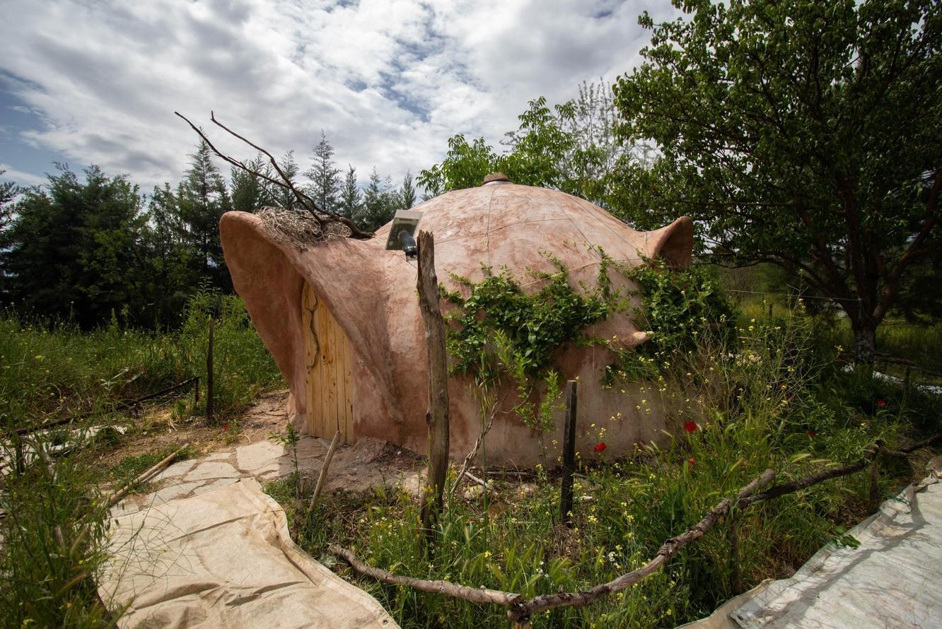
It is important for us to know that you agree in spending 8 months in such a simple and basic way of life.

2.1 Average Nessonas’ Weather
The average weather during winter is usually between 0-15 °C and during summer between 25-35°C.

3. Travel Information
Our farm is located at Nessonas (Zip code: 40006) a small village near the city of Larissa, in central Greece. It is 15 km from Larissa, the 5th largest city in Greece.
This is the exact location of our project: 39°43'44.0"N 22°32'40.1"E
Closest Airports:
- Thessaloniki (EO Aerodromiou Thessalonikis airport) - 171 km distance
- Athens (Eleftherios Venizelos international airport) - 385 km distance

Train:
If you arrive at Athens airport, you can take the train to Larissa from Athens' railway station “Larissa station”.
To get there you can directly take the suburban train from the airport and stop at the “Larissa station” station. Another option is to take the subway towards the city center and change to the red line at the station “Syntagma '' and then go towards the station “Larissa station”. These are the most convenient options but there is also an alternative to get to “Larissa station” by bus. You can check google maps for more transportation options.
If you arrive at Thessaloniki airport you can take the bus Χ1 to the train station during daytime, or the bus N1 to the train station during late hours.
Thessaloniki’s train station has frequent departures to Larissa and it takes less time than the bus.
Bus:
If you arrive at Athens airport, you take the subway, either the bus to the center and you should reach “Liosion bus station”. There, there are buses heading towards Larissa quite frequently.
You can check this website for more info: https://www.trip2athens.com/practical-info/citytransport/attraction-18/#tab-1
If you arrive at Thessaloniki airport, you can take the X1, or N1 bus and head towards the center. From there, you can catch a bus and go to the “KTEL” bus station . This is where the buses to Larissa start from. You can check this website for more info on timetables and buses: https://www.ktellarisas.gr/

Travel durations & COSTS:
Athens airport → “Larissa station” Train station
Duration 30 minutes approx. (every 1 hour approximately) COSTS: ~5-10€ Athens Station → Larissa train station
Duration 3-4 hours (many daily connections) COSTS: ~13,5 - 41,5€ Thessaloniki airport → TrainOSE
Duration 40-50 min (every 30 min connection) COSTS: ~2€ Thessaloniki DEPARTURE PLACE → Larissa
Duration 1:40 hours (every ½ to 1 hour connection approximately) COSTS: ~10-30€ Bus:
Larissa → Nessonas (Sykourio)
DURATION 30min (every one or two hours connection bus): COSTS: ~2 €
IMPORTANT: You will take the bus to Sykourio and you will ask to get down to the village of “Nessonas”.
From where the bus leaves you, our farm is a 5 min distance on foot. So if you follow the GPS coordinates you will arrive easily at the activity venue. In case you need assistance you can contact us at our telephone numbers. Either way, we are going to check every now and then at the bus station for new arrivals.

Useful links:
https://www.hellenictrain.gr/en
https://ktelast-larisas.gr/indexeg.php
https://www.thisisathens.org/getting-around/public-transportation-metro-bus-tram

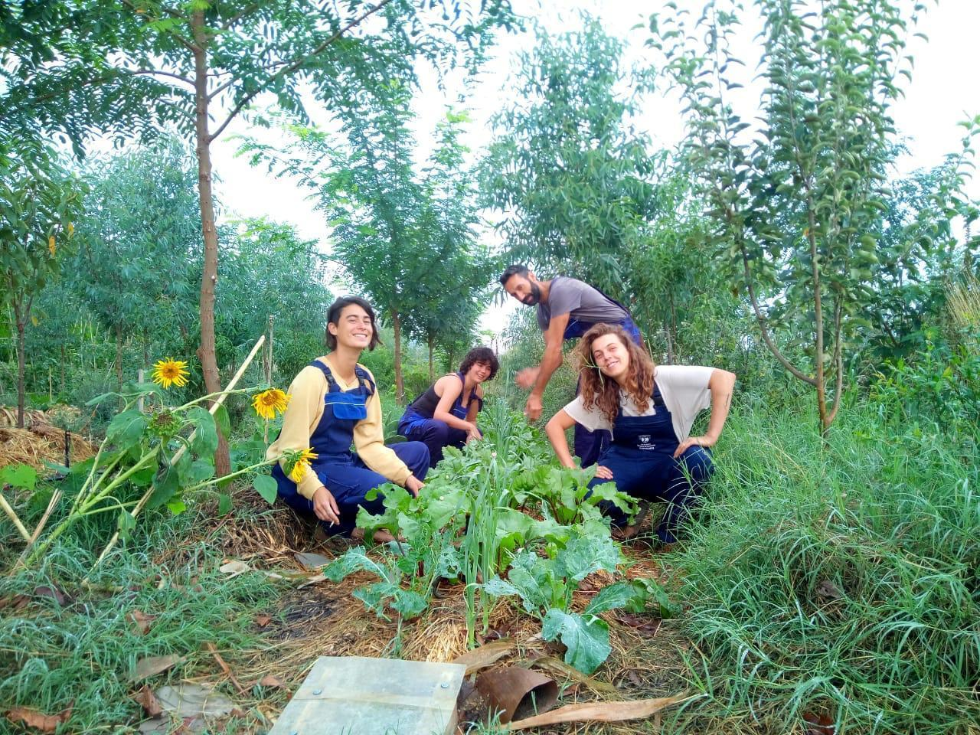

→ The best is to arrive in Nessonas village at around 7 - 8 pm!

While preparing your travel keep in mind:
● Since we need your original tickets to reimburse you with the travel money (go and back included) please book your tickets online as early as possible so that we can have the pdf original copies of your ticket before your departure. If booking online is not available, please take a picture as soon as you buy your ticket at the box office and make sure to have a ticket copy and the receipt with this piece of information: your name; the starting and finishing place of the journey; the date of the journey and the price of the ticket. If the ticket is booked online please bring two printed copies (one for you and one for us)! Our coordinator will collect all the tickets and provide us with a file with all the travel information and costs of each ticket.
We can’t reimburse travels without tickets in original copy or pdf
● Your final destination will be the bus stop in the center of Nessonas village, from where we will pick you up. Please inform us of your arrival time and travel details via email before your departure.
● Your travel should last no more than one day to go and one day to return (a total of 2 days roundtrip) and you definitely HAVE TO BE HERE when the activity starts! You are also eligible for GREEN TRAVEL (bus, train, car-pooling/car-sharing, boat) that adds up to 4-6 days roundtrip.
COB eco-project on the map: 39°43'44.0"N 22°32'40.1"E
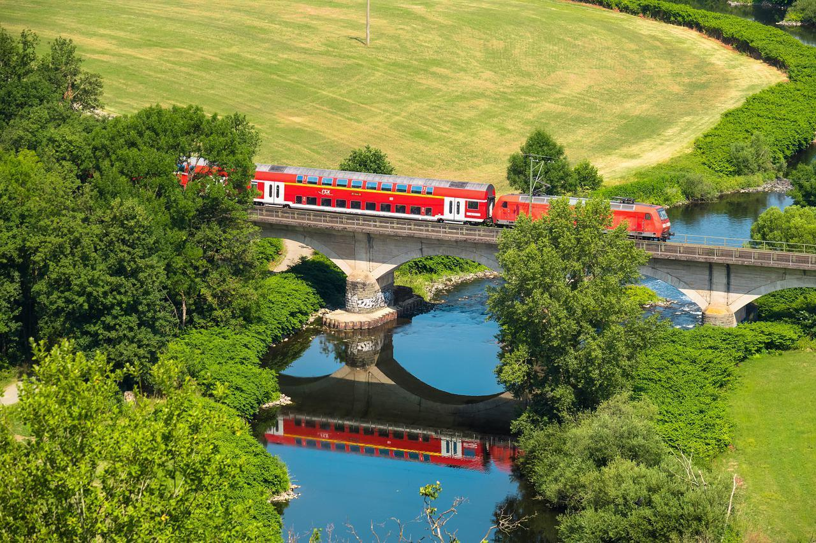

TRAVEL REIMBURSEMENT
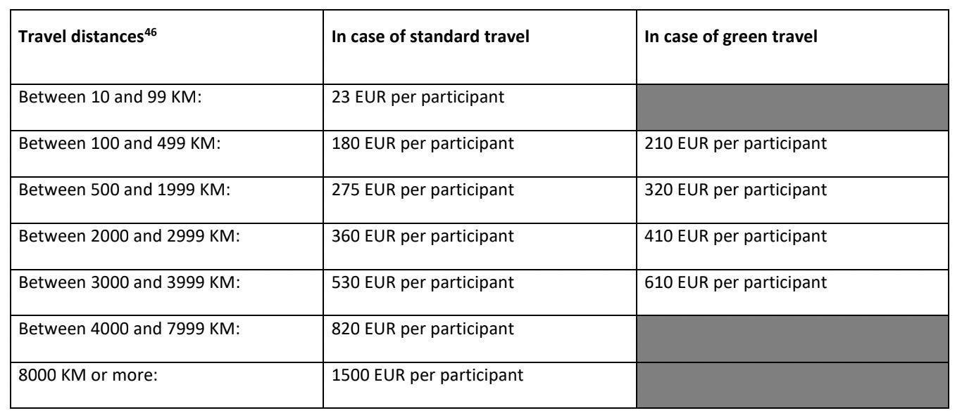
Travel costs will be covered up to the maximum eligible travel distance cost. Your travel budget depends on the distance you have to travel in order to get to the volunteering venue. Please remember to keep all the original travel tickets and give them to our coordinator, who will reimburse you up to 3 weeks after your arrival.
Travel Refund up to:
Use this website to calculate your travel distance from you place of residence to the activity venue: https://erasmus-plus.ec.europa.eu/resources-and-tools/distance-calculator

You should travel to Nessonas on the 14th February (arrival day) and leave on the 27th September (departure day) otherwise we can’t refund the travel costs (except if you choose the Green Travel option, 2+2, 0-4, 1-3, 4-0, 3-1 days arrival and departure). It’s not possible to participate as a co-funded participant if you don’t participate in the whole duration of the activity.
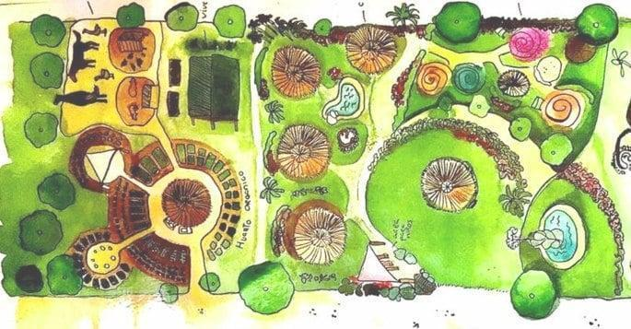

4. What To Bring
● Sleeping Bag
● Air or fitness or camping MATTRESS and pillow (or/and anything you need for being comfortable sleeping on the ground in a tepee)
● towel for shower
● reusable water bottle
● Clothes that can get dirty
● Swimsuit and towel (if you are interested in saunas and pond swims)
● Hat (to protect against the sun)
● Flash lights
● Raincoat and warm clothes (the weather can quickly change)
● Comfortable shoes and clothes for outdoors, walking and being outside
● Camera with a cable to share pictures (if you want and have)
● Ecological and biodegradable shampoo, toothpaste and soap, suitable for the internal sewage system (if you don’t have such, don’t worry, we can provide hygiene products that are both ecological and biodegradable - 3.5 euros/toothpaste, 4 euros/soap).
● Ecological and biodegradable clothes detergent, suitable for the internal sewage system (we can also provide this for 3euros/soap)
● Your special needs, like tobacco, medication, etc (the nearest small shop is a 3 kilometers walk)
● Bring any material you need to implement the activities you want to share during the course, such as musical instruments, games, dances, songs and stories…

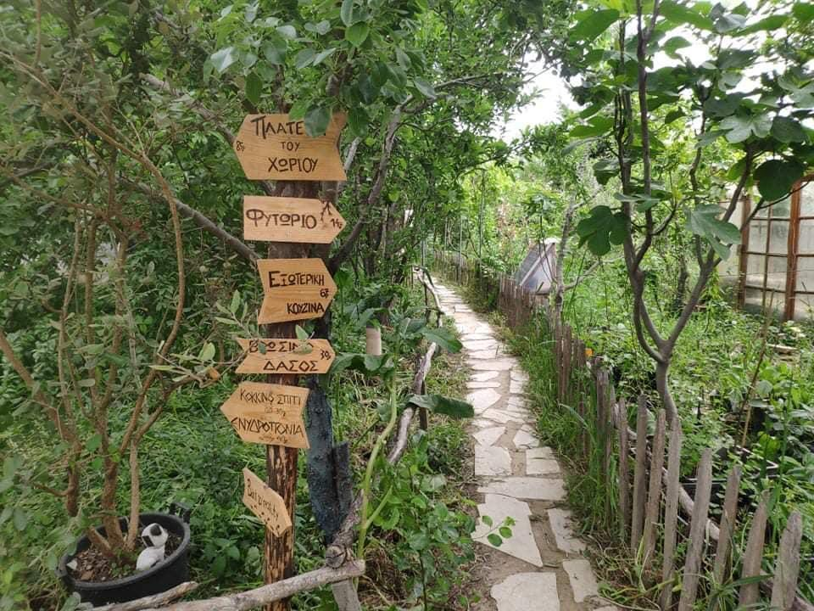
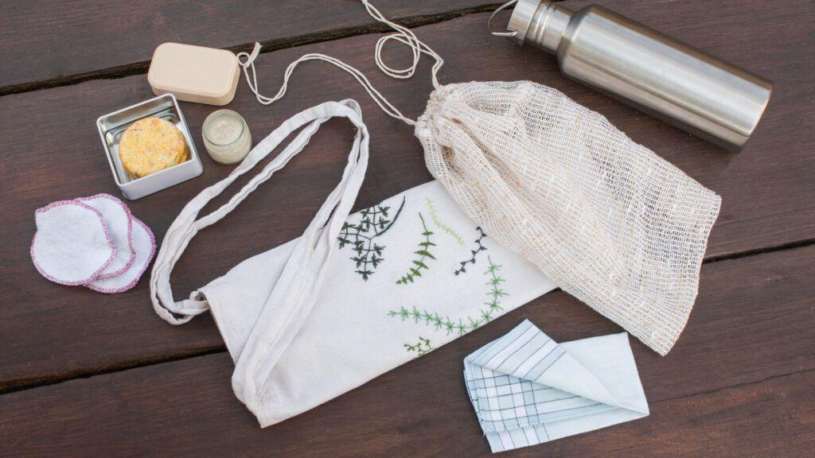

5. Activities
Participants in this course will be involved in the following activities:
- Learning hands-on how to construct buildings with different natural building techniques (adobe bricks, wood, wattle and daub, cob, earthbags, rammed earth, etc)
- In terms of sustainable development and permaculture ethics, learning how to live in healthier, low-footprint homes. Gathering local natural resources and building constructions like ovens, dehydrators, rocket stoves, etc
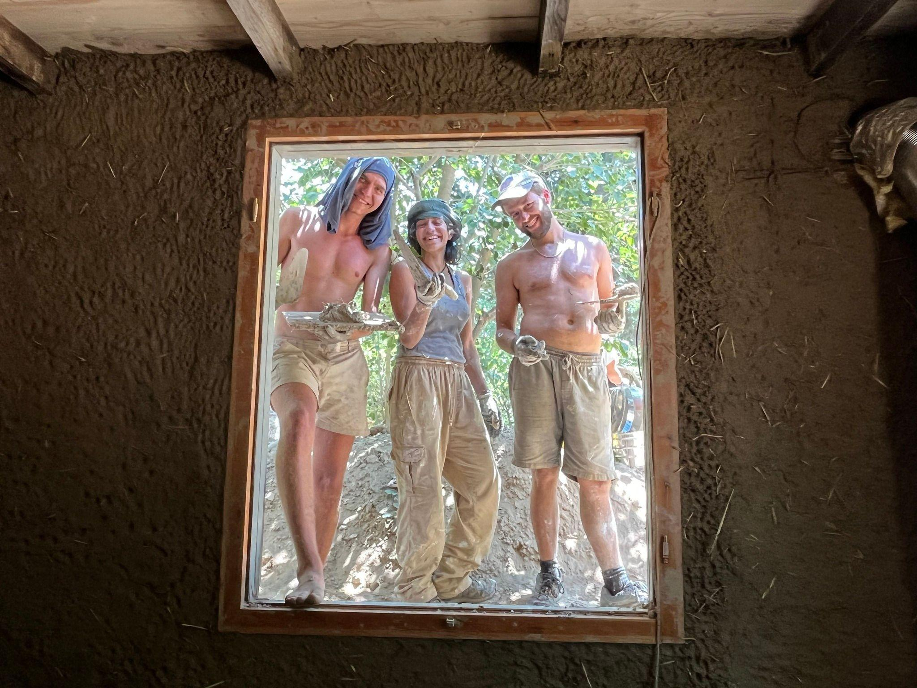
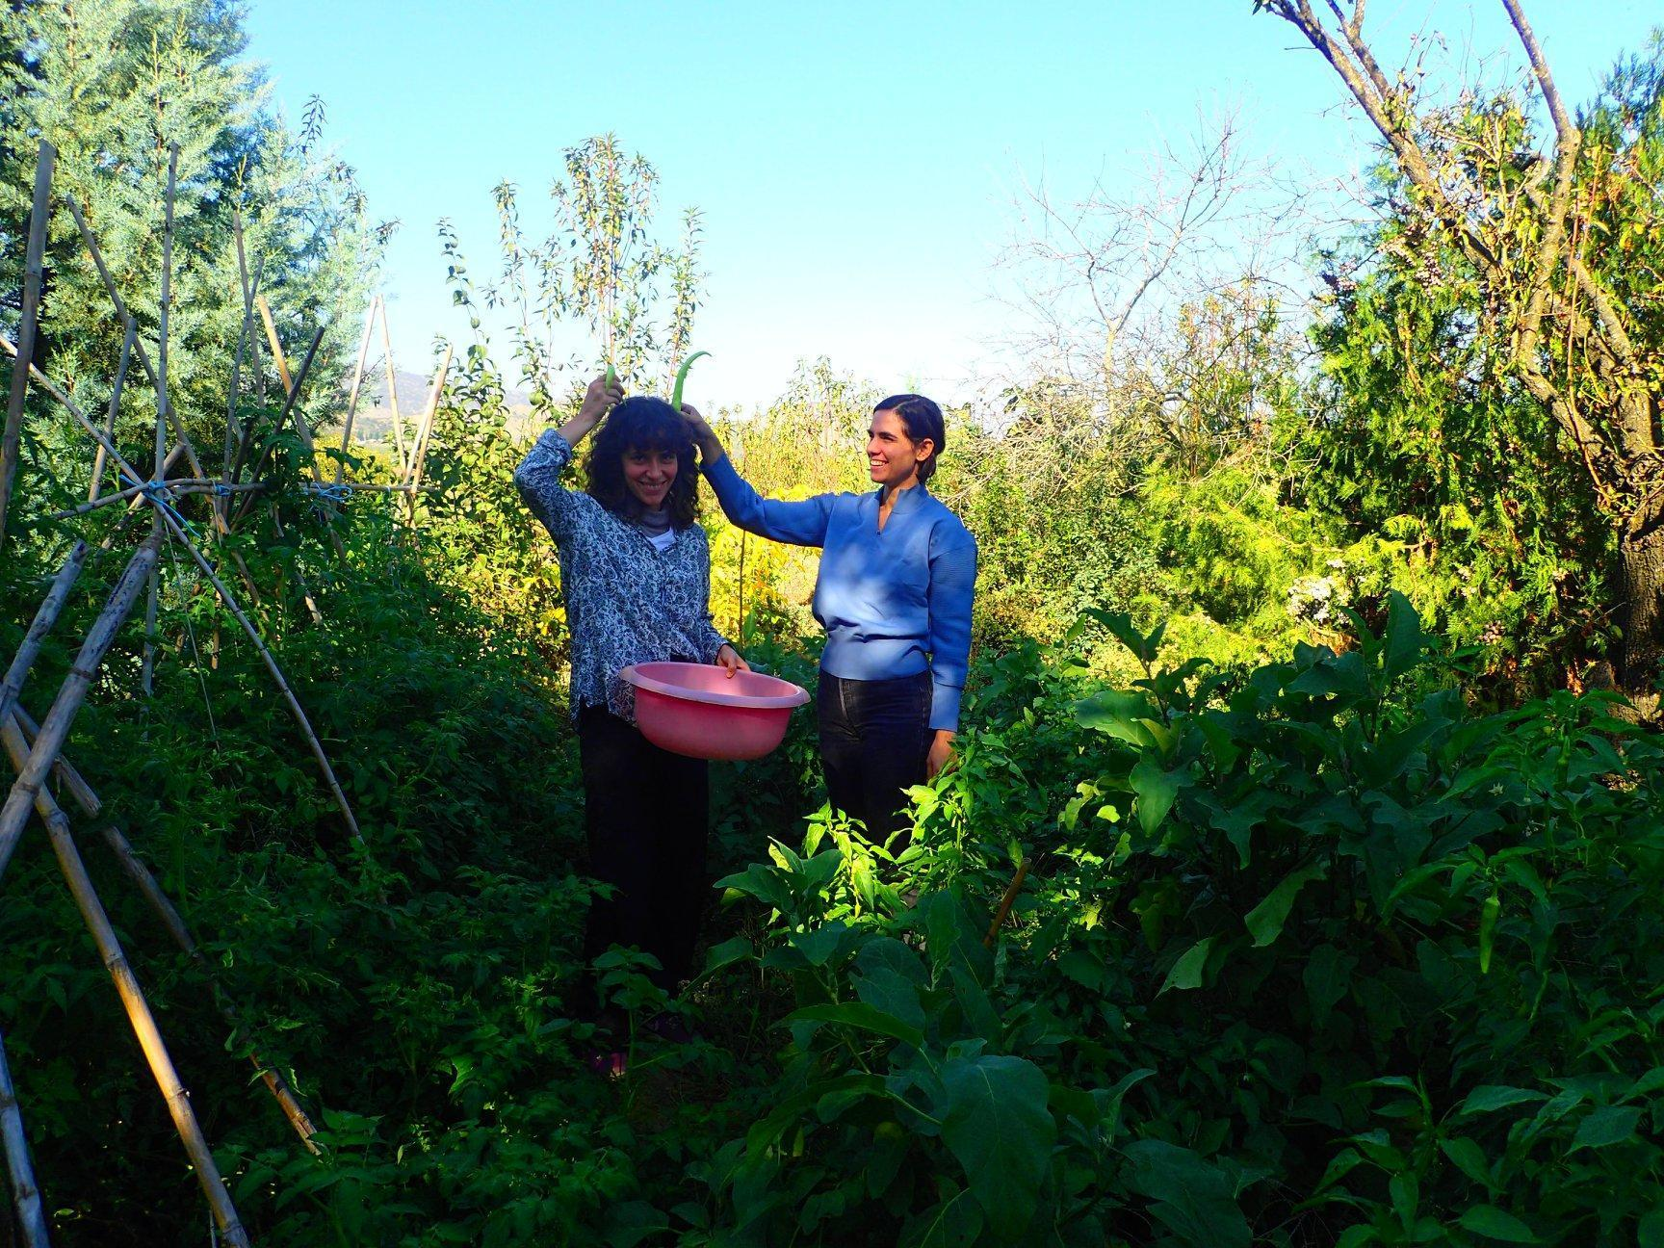

- Community life. During the project, the people living in the same space will share responsibilities (Cooking, cleaning of common spaces, etc), personal space and everyday activities concerning village life.
- Educational excursions to other farms and projects in Greece, so that the participants get to see more examples in practice
- Organizing workshops for children and adults about self-sufficiency
- Fabricating natural cosmetics (soaps, toothpaste, ointments, etc)
- Regenerative Agriculture and Farming activities: Beekeeping, nurseries with traditional seeds, preparation of vegetable beds, composting, soil building, Agroforestry, Food forests and syntropic farming, etc.
- Food processing: Dehydrating and fermenting fruits and vegetables, making preserves, marmalades, pickles, sauces, cider vinegar, etc.
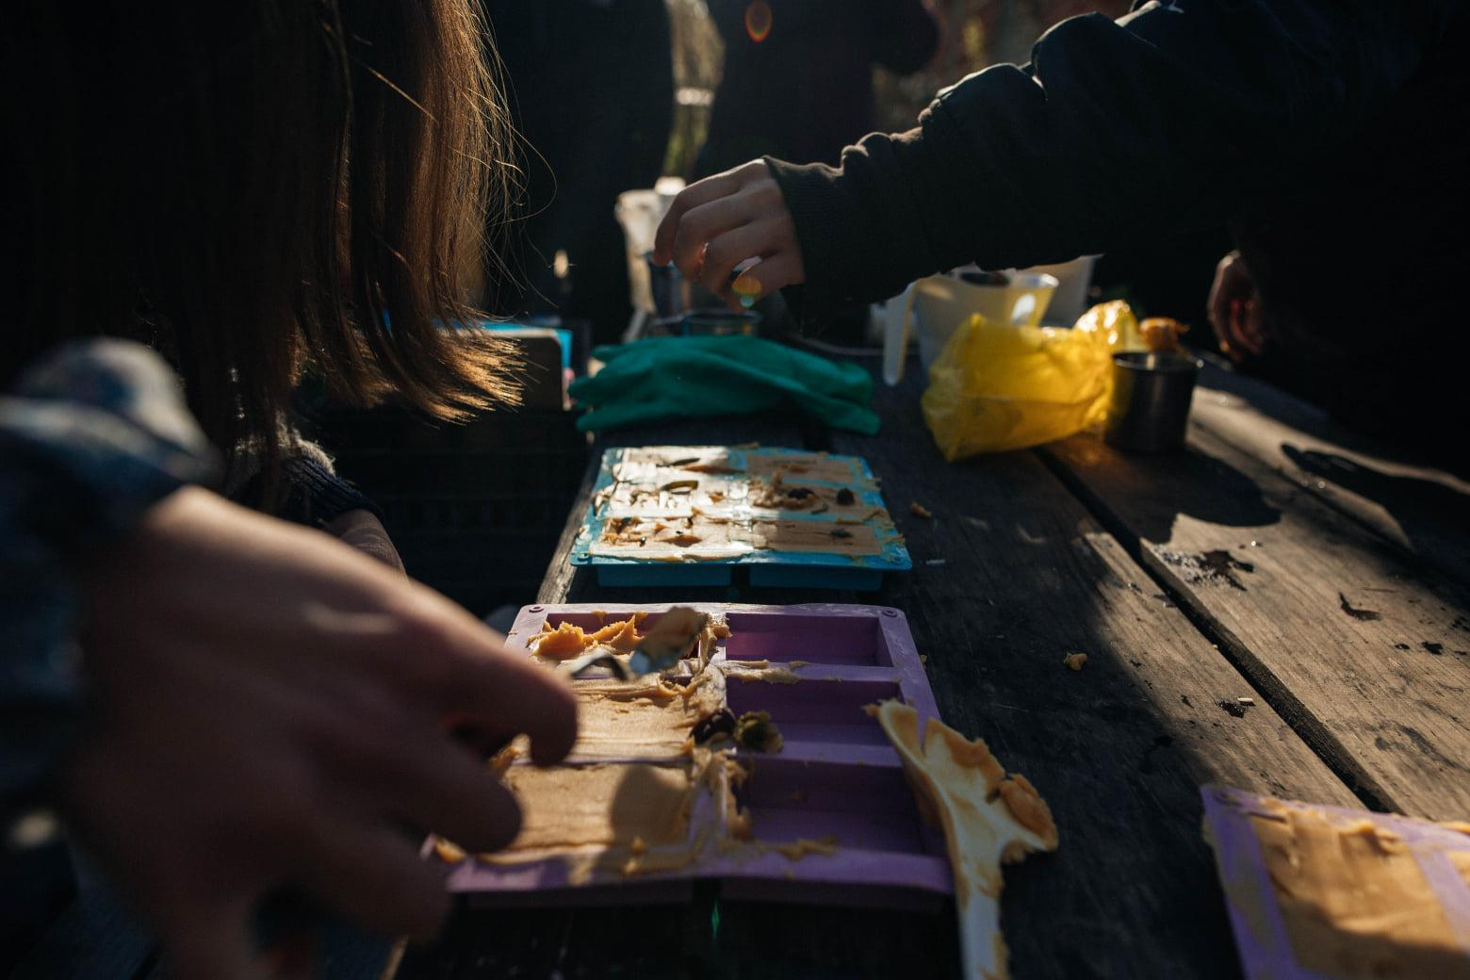
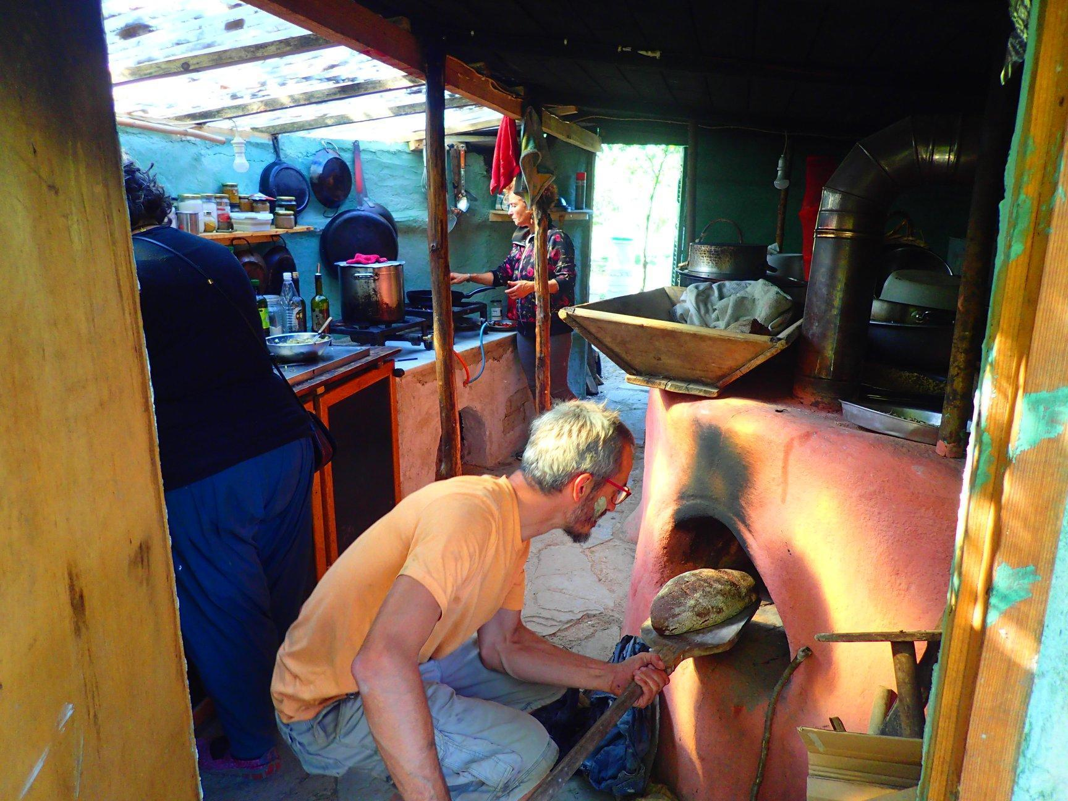

- Animal rearing: Everyday care of the poultry (Feeding, cleaning, etc)
- The Green Basket project: Every week we will deliver baskets filled with fresh vegetables, fruits, cosmetics, and processed food to consumers within the closest city, as part of our Community Supported Agriculture (CSA) project
- Permaculture Design of Ecosystems: Learning how to holistically design spaces so that they use the minimum of resources and transition to resilient habitats.
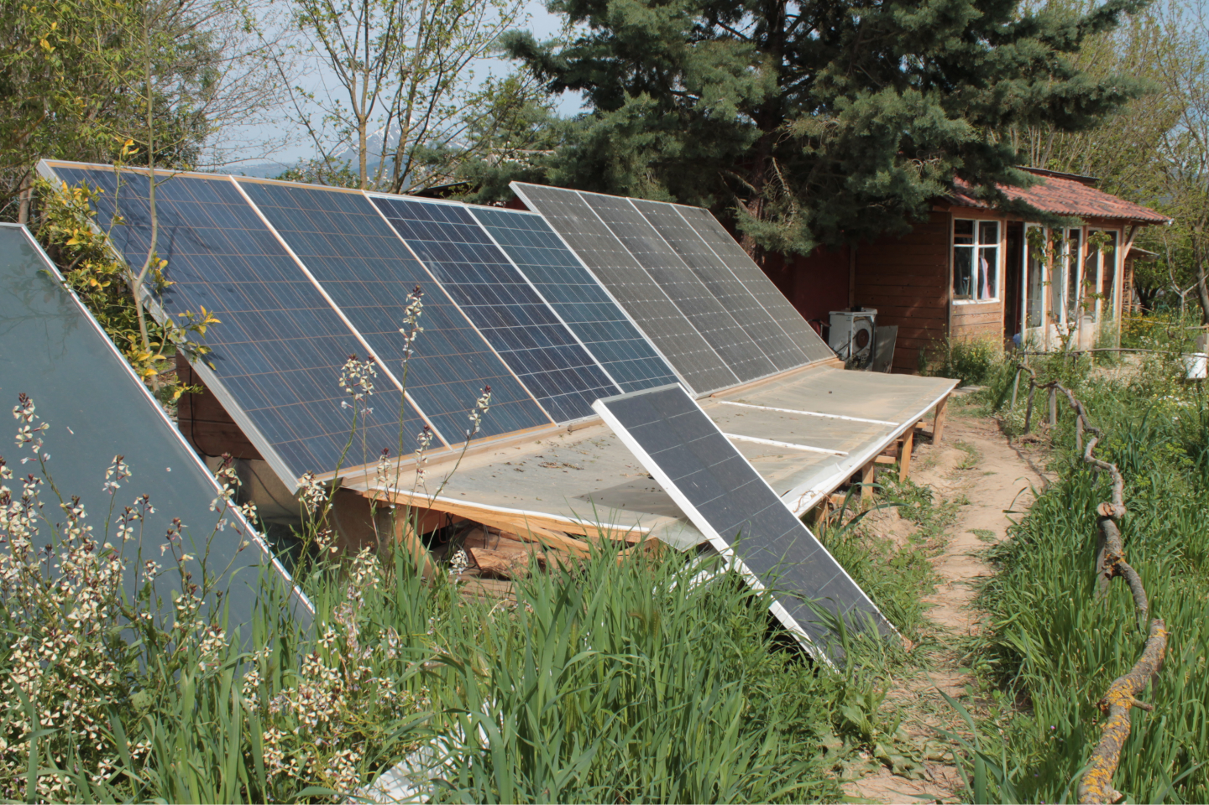
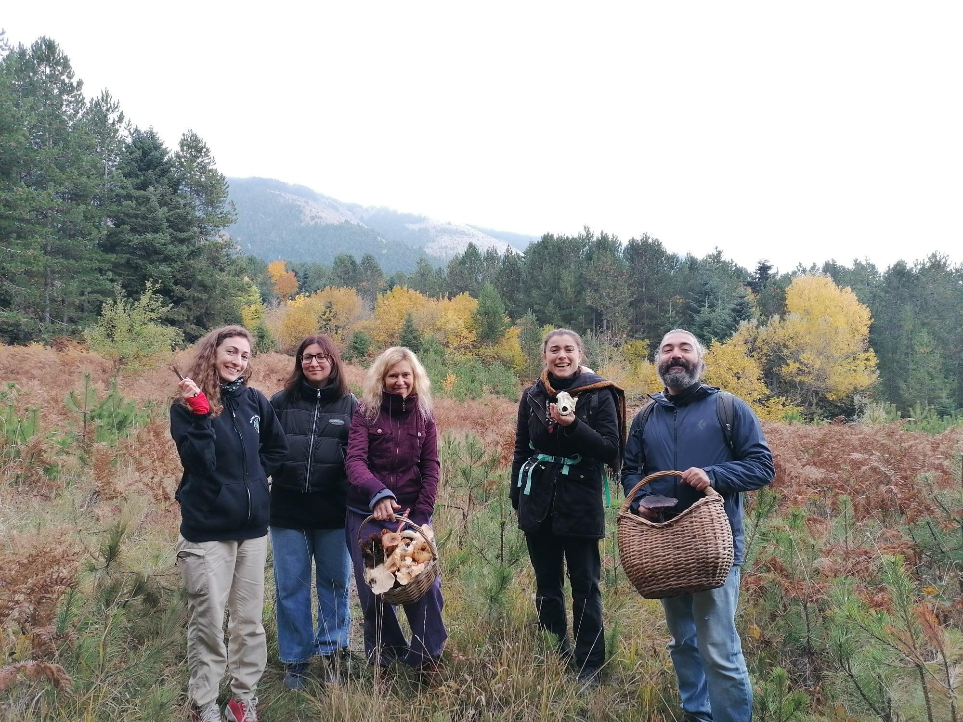
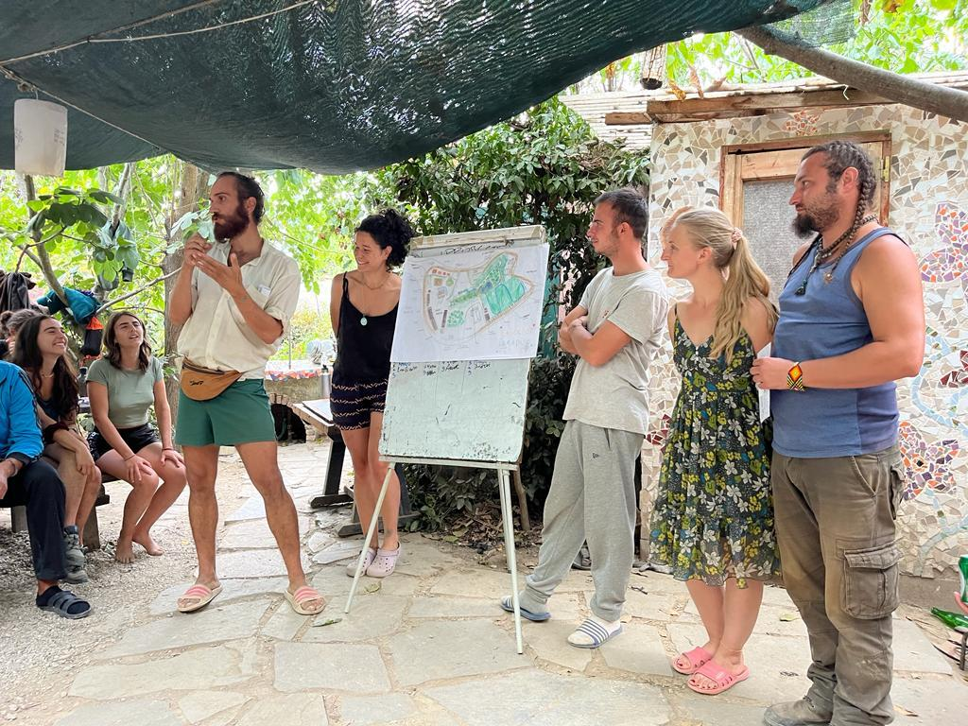
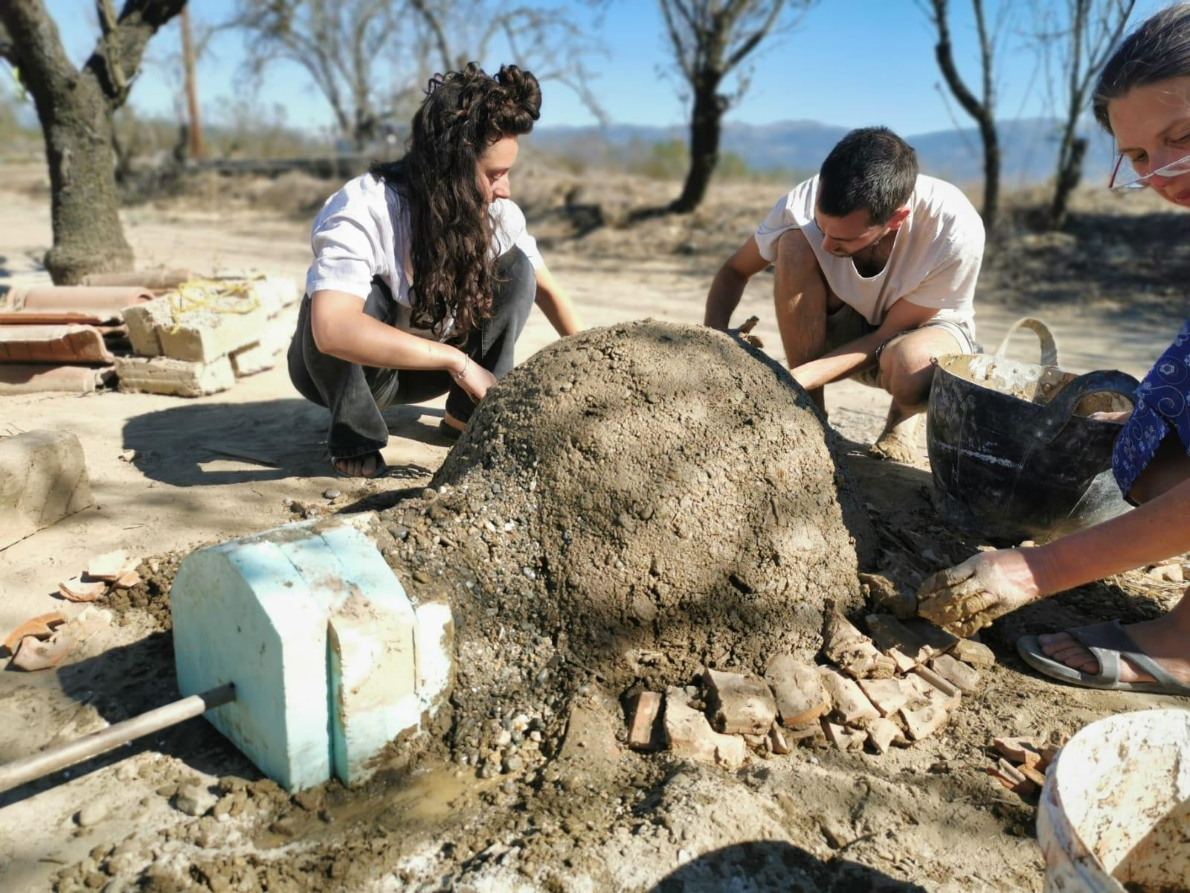

And much much more…..!!!!!!!!

6. DISCLAIMER
6.1 Health Insurance
You need to apply for the European Health Insurance Card. If you are not eligible for the EHIC, Henner will be your primary insurance. Check with your supporting organization for further information.
7. Confirmation

*APPLY HERE *

You will wait for confirmation or you will be asked for more information or an interview.
Once accepted, to finalize confirmation, you have to arrange to book tickets ASAP.

The Social cooperative “COB eco-project ” is the organizer of this European Solidarity Corps Long-term volunteering project and has applied for funds for the implementation of this, therefore the activity is co-funded by the European Union. This fund covers food & lodging, travel costs, coordination fees and organization costs.

Thank you!

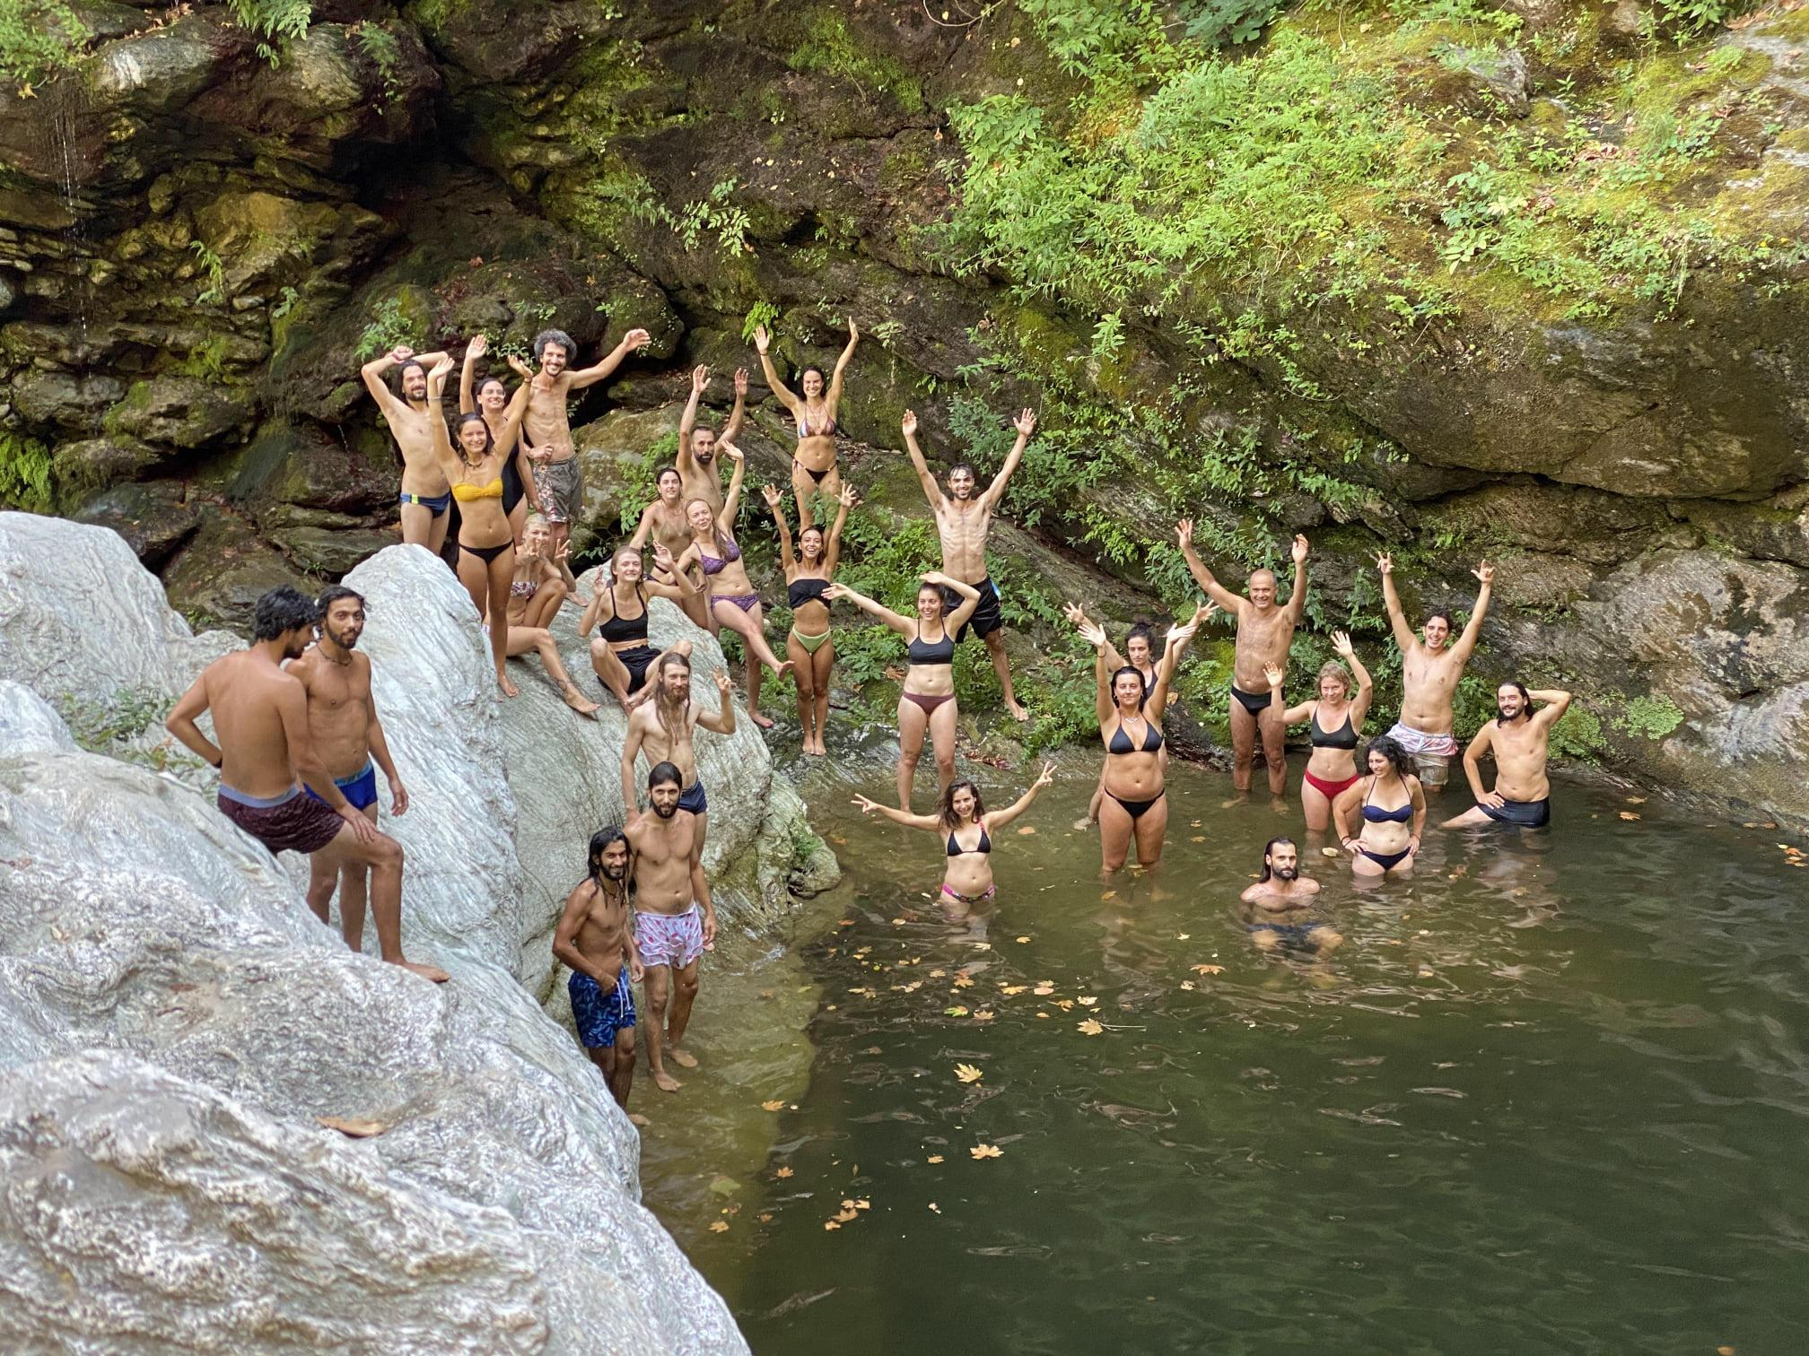
The COB eco-community is looking forward to receiving you, learning, working and growing together!

FOR MORE INFO:

Website: www.cob.gr

Facebook: @building with earth

Instagram: cob_gr
If you have any questions, we will be happy to answer!

